Paula De Francisco Pérez  AI-First Growth Marketer · Experiments · Claude & MCP  Dubai, UAE | +971 50 386 3656 | paulich98@hotmail.com  linkedin.com/in/paula-de-francisco-perez-92a13119a  Portfolio: paula-de-francisco.vercel.app  Nationality: Spanish | UAE Employment Visa (employer-sponsored) | 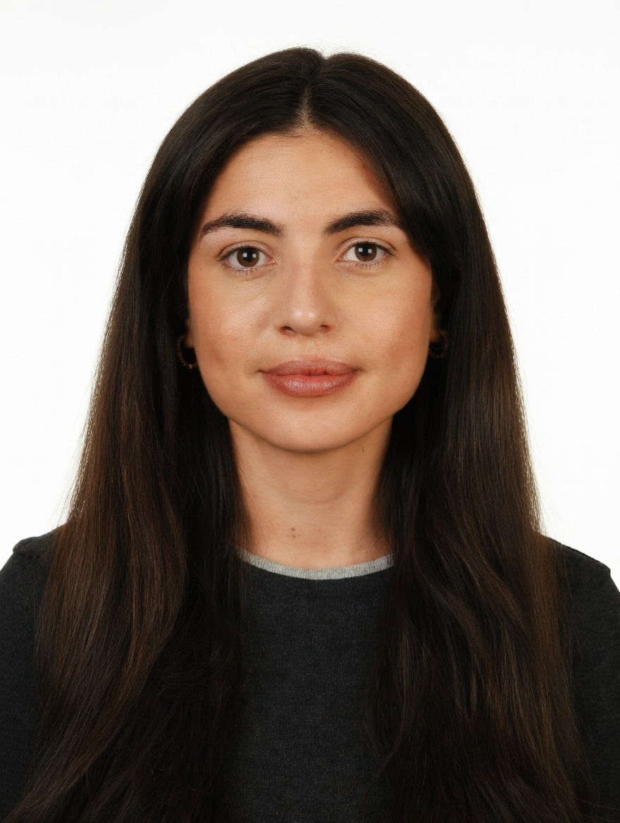
PROFESSIONAL SUMMARY

AI-first growth marketer who builds the stack hands-on with Claude Code and MCP integrations. At DoFreeze, a Claude-based system runs campaign planning, content and reporting (~40% less manual work), and every idea is judged on incremental sales: a purchase-to-enter talabat giveaway beat its control brand +165% to +4.7%. Started out in an accounting department (SAP, Looker).
WORK EXPERIENCE

Brand & Marketing Manager | Oct 2025 – Present
DoFreeze LLC · UAE F&B / FMCG group | 7 brands incl. Befit, Eurocake, SMASH | sold on talabat, Noon, Careem · Dubai, UAE
• Built a Claude-based system that automates campaign planning, content, market research and KPI reporting (~40% less manual work); landing pages built with AI agents; an AI avatar briefs affiliates in several languages
• Giveaways measured like experiments: a purchase-to-enter cashback draw with talabat lifted SMASH daily sales +165% vs +4.7% for a control brand; another bought followers at AED 0.73 each, 8x cheaper than a promoted reel
• Influencer channel from zero: 103 creator activations at AED 81 per content piece (market AED 1,000–3,500); audited the agency report, found reach estimated not measured, and micro-creators at 10–40x the campaign average
• Weekly creative-hook tests across 4 social accounts; Befit Crew affiliate programme (personal codes, tiered commissions); running, padel and yoga communities; a Sun & Sand Sports x Fabletics session that led to a listing proposal
• Scale or stop on data: computed break-even ROAS net of marketplace fees and moved Google spend to Meta; Advantage+ retargeting at 3.7x ROAS in week one; web orders +86% after reviews, bundles and a replenishment flow
Key Account Manager – Beauty, Fragrances & Fashion | Nov 2023 – Oct 2025
Miravia & AliExpress (Alibaba Group) · Marketplace | Beauty & Health department · Madrid, Spain
• Spotted the Arabian-perfume trend and onboarded 30+ sellers in two months (incl. Lattafa and Arabian Oud distributors), making it a top-growing sub-category
• Grew 42 beauty and fragrance brands (incl. L'Oréal Paris, Maybelline, NYX, Redken, KIKO Milano) +30% GMV QoQ; created Hot on Social, a monthly trend showcase; worked with marketing, product and ops
Account Manager – XL Accounts | Sep 2022 – Nov 2023
Glovo · Food delivery marketplace | 10K+ employees · Madrid, Spain
• Co-managed 5 XL restaurant accounts (KFC, Taco Bell, Vicio) on GMV, orders, promo spend and in-app ads
Early Career | 2019 – 2022
Mondelez International · Línea Directa Aseguradora · Global FMCG | Spanish direct insurer · Madrid, Spain
• Category Planning Trainee, Mondelez (Aug 2021 – Aug 2022): sell-in/sell-out and promo-effectiveness analysis, NPD support
• Accounting Intern, Línea Directa (Jan – Dec 2019): a year inside an accounting department, working in SAP and Looker
CORE SKILLS & TOOLS

Growth | growth experiments, giveaway mechanics, creators & affiliates, communities, paid social, email
AI & Build | Claude Code, MCP integrations (Shopify, Meta Ads, Gmail, Notion, Canva), AI agents, AI landing pages
AI Search & Content | AEO / GEO (schema markup, Wikidata, llms.txt), prompt engineering, content, Shopify, CRO
Data & Analytics | control-group tests, incrementality, break-even ROAS, ROAS, CPA, Looker, Power BI, Excel (Expert)
Tools | Claude, ChatGPT, Higgsfield & Hailuo (AI video), Canva, Photoshop, Meta Ads Manager, SAP
EDUCATION

Bachelor's in Business Administration — CUNEF Universidad, Madrid | 2016 – 2020
Specialisation: E-Commerce · Fashion Industry · Thesis on e-commerce in fashion retail (9.5/10)
Google E-Commerce Certificate · Google Digital Marketing Certificate
LANGUAGES

Spanish | Native | English | Professional C1

